AP Biology Name __________________________
Chapter 52 Guided Reading

- Define the following terms:
  - Population
  - Density
  - Dispersion
  - Mark-recapture method
  - Immigration
  - Emigration
  - Territoriality
- What are the three patterns of dispersion and what conclusions can you draw from these patterns?
- Define the following terms:
  - Demography
  - Life tables
  - Survivorship curves
  - Reproductive table
  - Life history
- Use the diagram below – label the three different survivorship curves – give an example of an animal that fits the curve and an explanation of why they fit the curve.
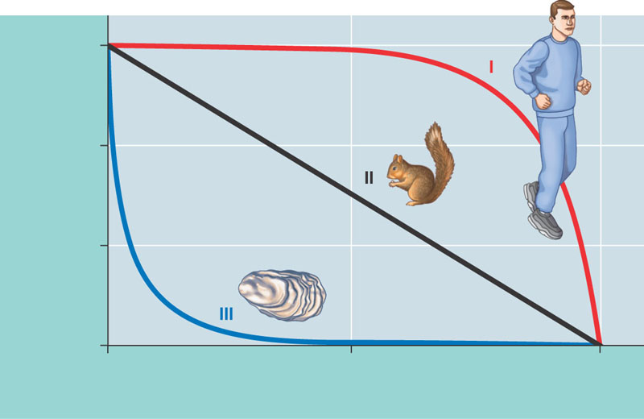
- Compare and contrast semelparity and iteroparity – give advantages of each as they apply to an example organism – focus on the adaptive benefit of the life history. Are there any disadvantages? This is a core concept.
- What is zero population growth?
- What is exponential population growth? What kind of graph would you expect to see?
- Read section 52.4 slowly – we are not focusing on all of the math but the concepts – explain the logistical population growth model. Studying the graph below – what does it tell you and why? How does “K” fit in to all of this?
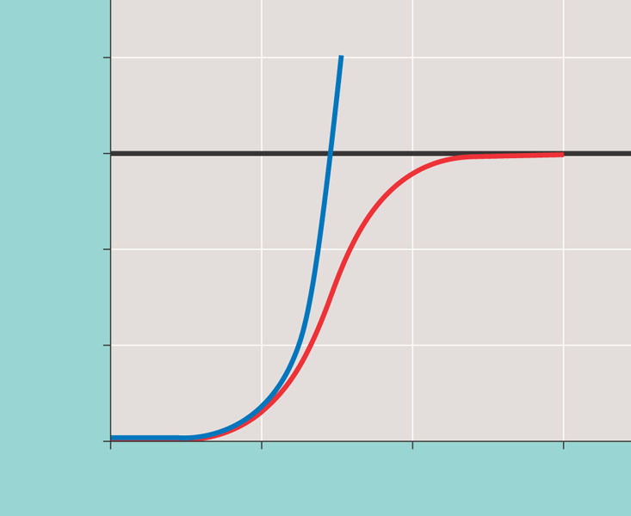
- Compare and contrast r and k selection – this is a key concept – do some additional research and try to come up with at lease six points of comparison.
- What is the difference between density-dependent and density-independent factors as a general term?
- What generalizations can be made by the graphs below?
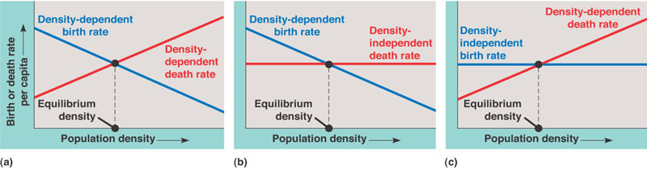
- Describe six density-dependent factors in population regulation.
- What is population dynamics?
- Describe human population growth after studying figures 52.22 and 52.23.
- What kinds of information do age structure pyramids provide and what inferences can be made from these?
- How can an ecological footprint be useful?

